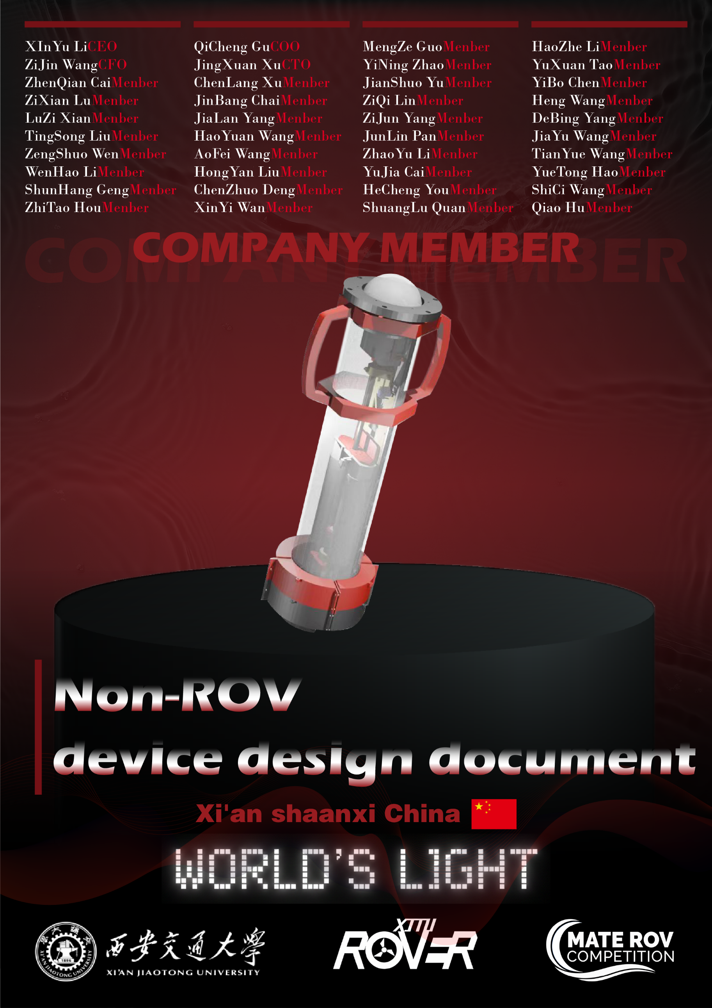

Non-ROV Device (Float)

This document summarizes the design of our **vertical profiling float** for **Task 4 (MATE Floats Under the Ice)**. The float is designed as an independent, electrically powered **non-ROV device** that performs repeatableascent/descent profiles and reports its status and sensor readings to a topside operator.

## **Design overview (buoyancy engine and sensing)**

Our float adopts a **leadscrew-driven transmission** as the core of its buoyancy engine. A motor drives a screw mechanism to actuate **two syringes** and therefore controls the float’s vertical motion by **pumping water in/out** **between the two syringe chambers**. By adjusting the internal water volume distribution, the float changes its effective displacement and achieves controlled **ascending** and **descending** without external tethers, which is suitable for the “under-ice” profiling scenario where reliable, self-contained motion is preferred. For closed-loop feedback, an **MS5837 depth sensor** is installed on the bottom plate to provide real-time depth measurements for profiling control and verification.

## **Control and communications**

The onboard controller is an **ESP32**, responsible for executing the profiling logic, reading the depth sensor, and managing system states. During operation and testing, the float can communicate with a topside computer via **Bluetooth serial (BLE/UART-style link)** for parameter configuration and status/data reporting. This wireless link provides a practical interface for monitoring the profiling process and collecting telemetry without additional external wiring, while the control logic remains on-board to ensure that the float can maintain safe behavior even if the communication link is intermittent.

## **Power and protection (battery + fuse selection)**

The power system uses **NiMH AA cells connected in series** to form a **12 V** battery pack. For personnel and equipment safety, the design objective is to keep the **maximum current below 2 A**. Therefore, a **2 A fuse** is selected as the primary overcurrent protection device. Based on our electrical calculation, the float **maximum** **current does not exceed 1.527 A**. Under the 12 V supply, the **maximum power does not exceed 18.375 W**,which confirms that the system operates within the intended electrical envelope and that the fuse rating is consistent with both normal operation and fault protection needs.

SID

